DCS Codex Mobile App
Use Case Diagram

Submitted to:

Prof. Ma. Rowena C. Solamo
Faculty Member
Department of Computer Science
College of Engineering
University of the Philippines, Diliman

Submitted by:
Borja, Kim
Pilipina, Jigger Angelo
Valencia, Ian Benedict

In partial fulfillment of Academic Requirements
for the course
CS 191 Software Engineering I
of the
1st Semester, AY 2017-2018
Unique Reference:
The documents are stored in the https://github.com/kimmu/DCS-Codex-Mobile-App.
File reference: https://github.com/kimmu/DCS-Codex-Mobile-App/blob/master/02-Requirements%20Engineering/DCS%20Codex%20Mobile%20App%20-%20Use%20Case%20Model.pdf

Document Purpose:
The purpose of this document is to model set of actions which the DCS Codex mobile application is capable of, along with the actors involved in it.

Target Audience:
This document is useful for developers who would like to extend the mobile application in the future.

Revision Control

History Revision:
Revision Date | Person Responsible | Version  Number | Modification
09/21/17 | Borja, Kim | 1.0 | Initial Document

System Name: DCS Codex Mobile App

Description: The students are the user of the system. An authentication is needed before they can use the system; they are going to be asked for their student number. They can view the calendar of events such as MP deadlines and exam dates. Only the administrator can add events to the calendar (manual manipulation through the database) as there is a need for verification, but the students can still request for events to be shown in the calendar. The students can view their pending requests; if rejected, the administrator shall inform the student and the student can now delete the rejected request. The student should also manually sync the system to the server using a “sync button” after sending for a request of event.

Use-Case Diagram:
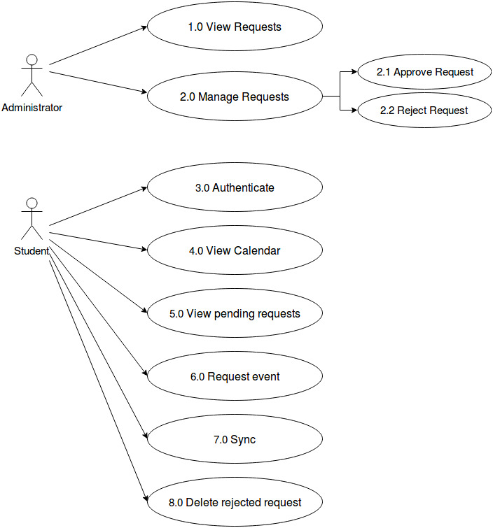

List of Actors:
Actors | Description
Student | The student is the user. He/she can view the calendar, request for additional events, sync the system to the server, view pending requests and delete rejected requests from the application.
Administrator | The administrator manually adds events to the calendar through the database.

List of Use-cases:
Use-Case | Description
Use-Case 1.0 View Requests | The administrator shall view requests from the students. This is done through the database.
Use-Case 2.0 Manage Requests | The administrator is responsible for managing requests from the students, either accept or reject the request. This is also done manually through the database.
Use-Case 2.1 Approve request | If the request is acceptable, the administrator is going to add the requested event to the calendar.
Use-Case 2.2 Reject request | If the request is rejected, the administrator is going to inform the student by indicating it in the list of pending requests.
Use-Case 3.0 Authenticate | The student should enter his/her student number.
Use-Case 4.0 View Calendar | The student can view DCS-related events in the calendar.
Use-Case 5.0 View pending requests | Status of pending requests can be viewed just below the calendar.
Use-Case 6.0 Request event | The student can request for an additional event in the calendar by filling in details of the event then pressing the “sync button” since syncing is only available whenever there is internet.
Use-Case 7.0 Sync | After requesting for an event, the student should sync the system to the server.
Use-Case 7.0 Delete rejected request | After being informed that the requested event is rejected, the student can now delete the request. An event is to be rejected if it is a hoax or another request has already been sent.

